**Example Queries**

1. **"What is the NVIDIA CUDA Toolkit?"**

**Response 1**

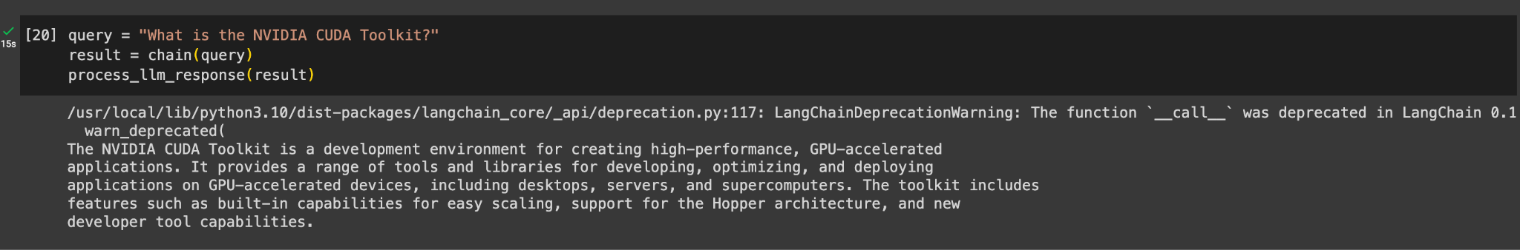

**Response 2**

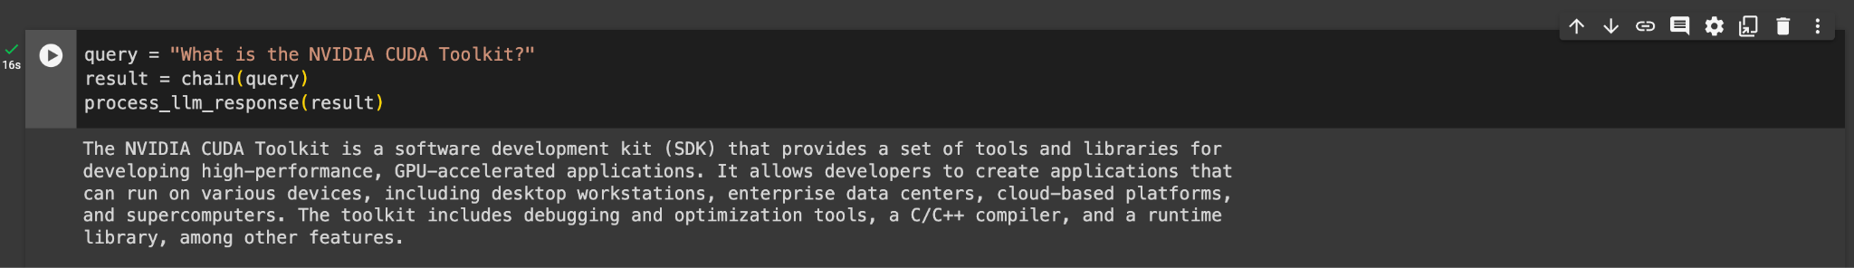

**Response 3**

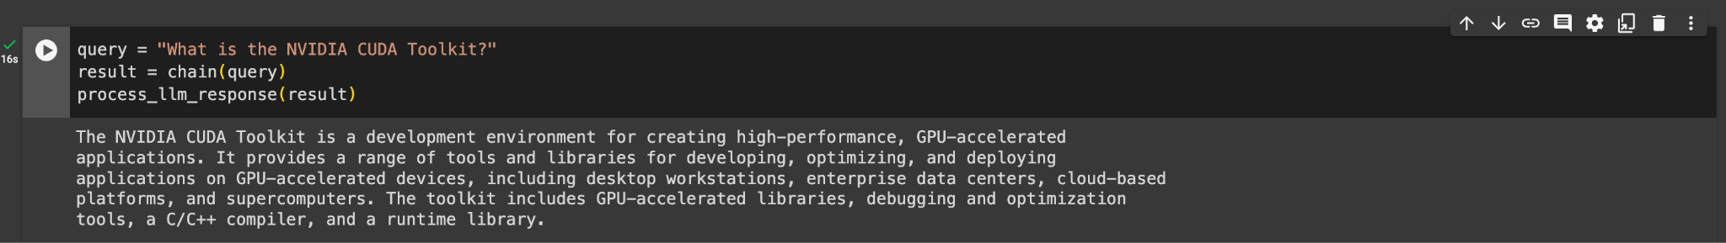

1. **"How can I install the NVIDIA CUDA Toolkit on windows?"**

**Response 1**

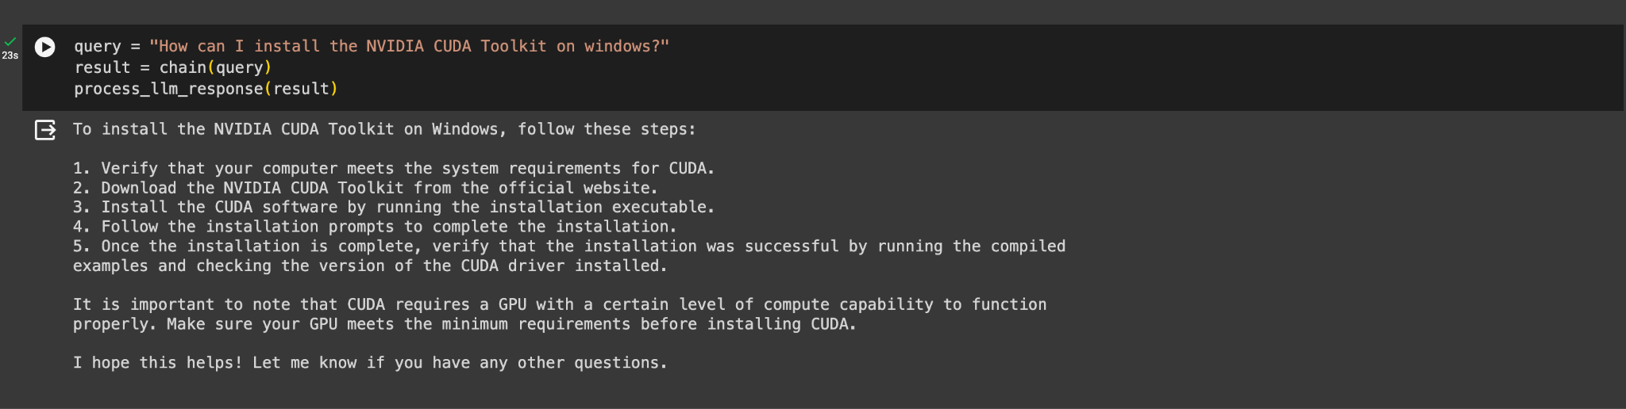

**Response 2**

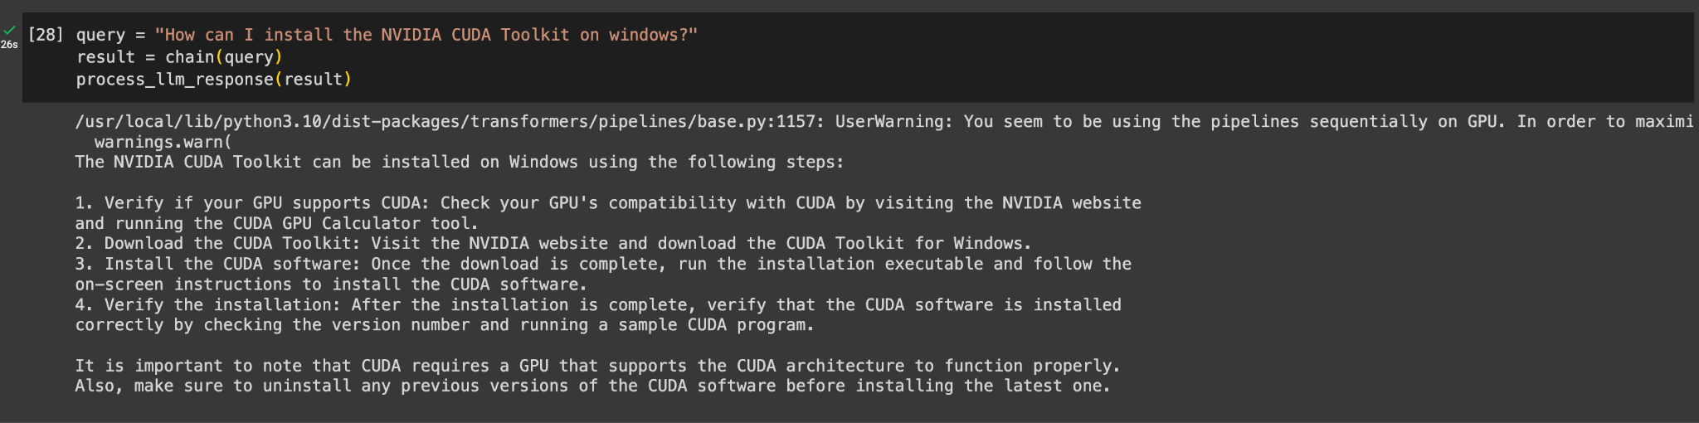

**Response 3**

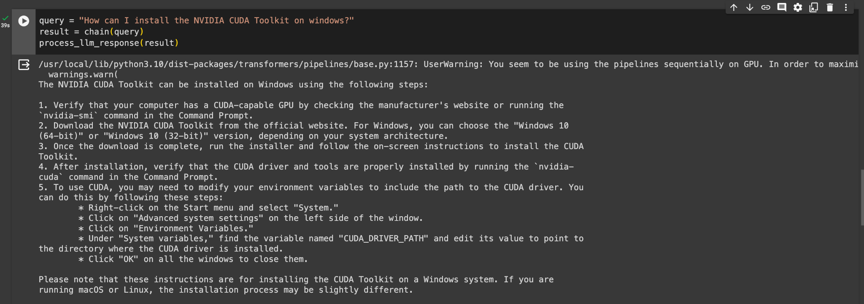

1. **"Can you give me some best practices using the NVIDIA CUDA Toolkit?"**

**Response 1**

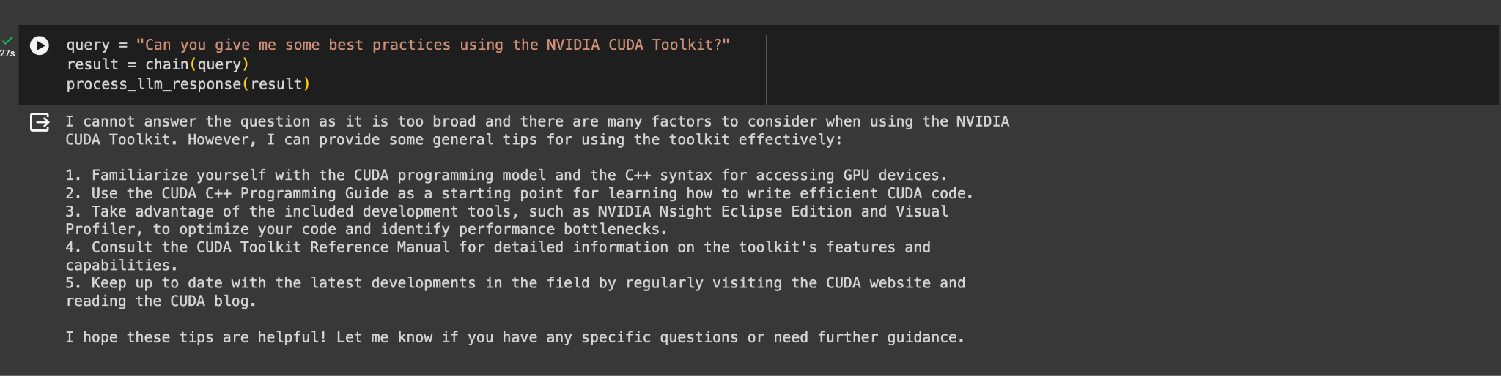

**Response 2**

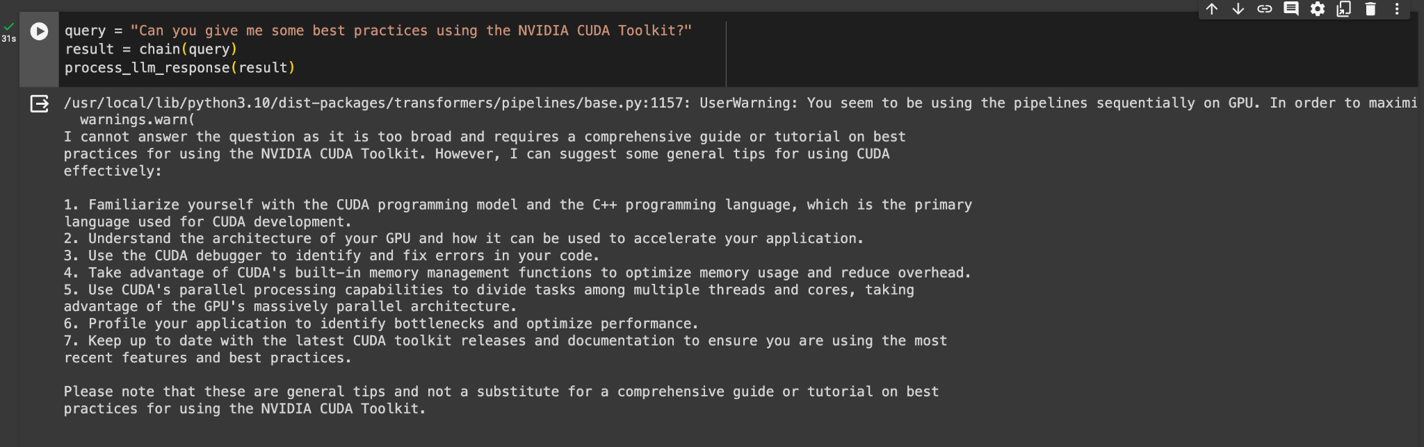

**Response 3**

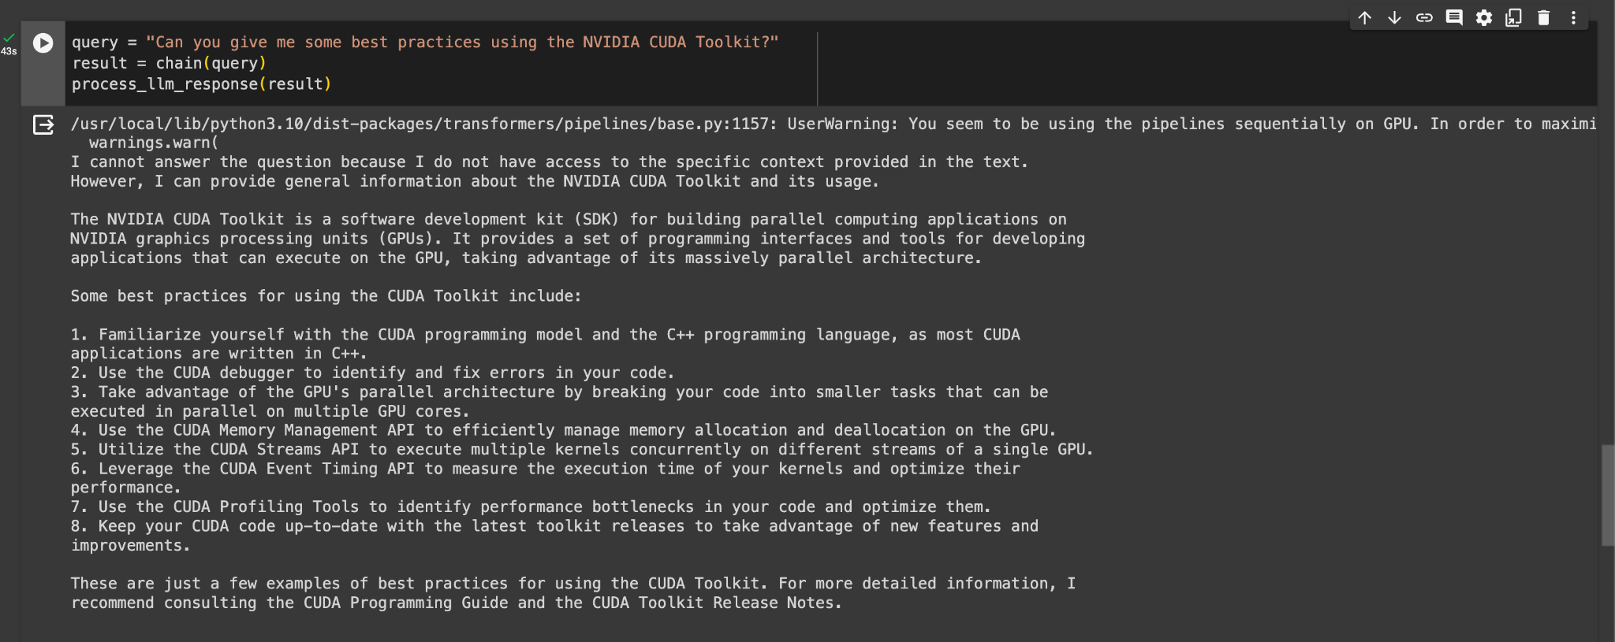

1. **"What is nvflare?"**

**Response 1**

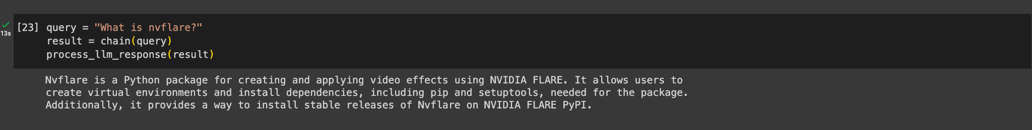

**Response 2**

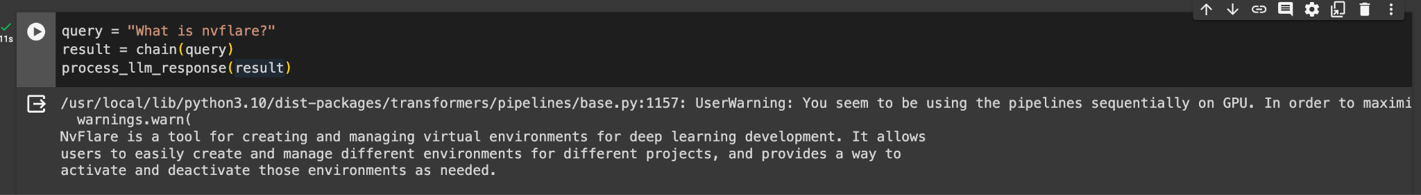

**Response 3**

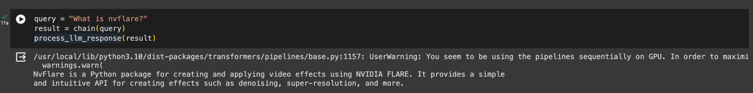

1. **"What is the difference between NVIDIA's BioMegatron and Megatron 530B LLM?"**

**Response 1**

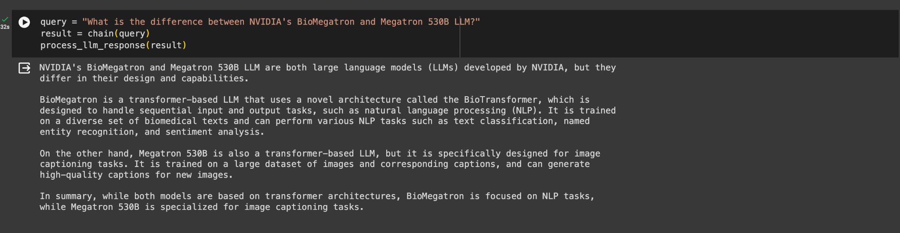

**Response 2**

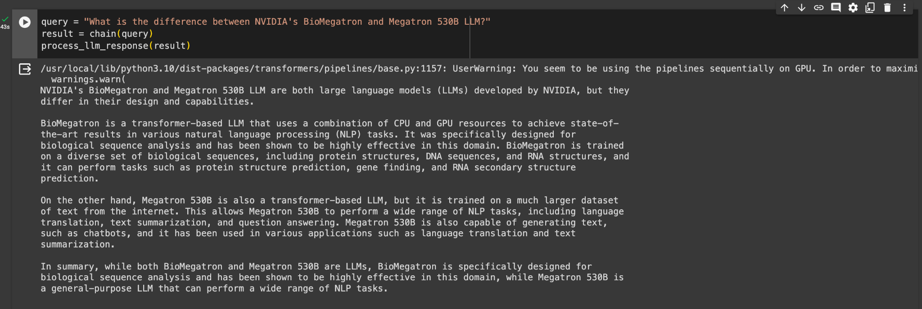

**Response 3**

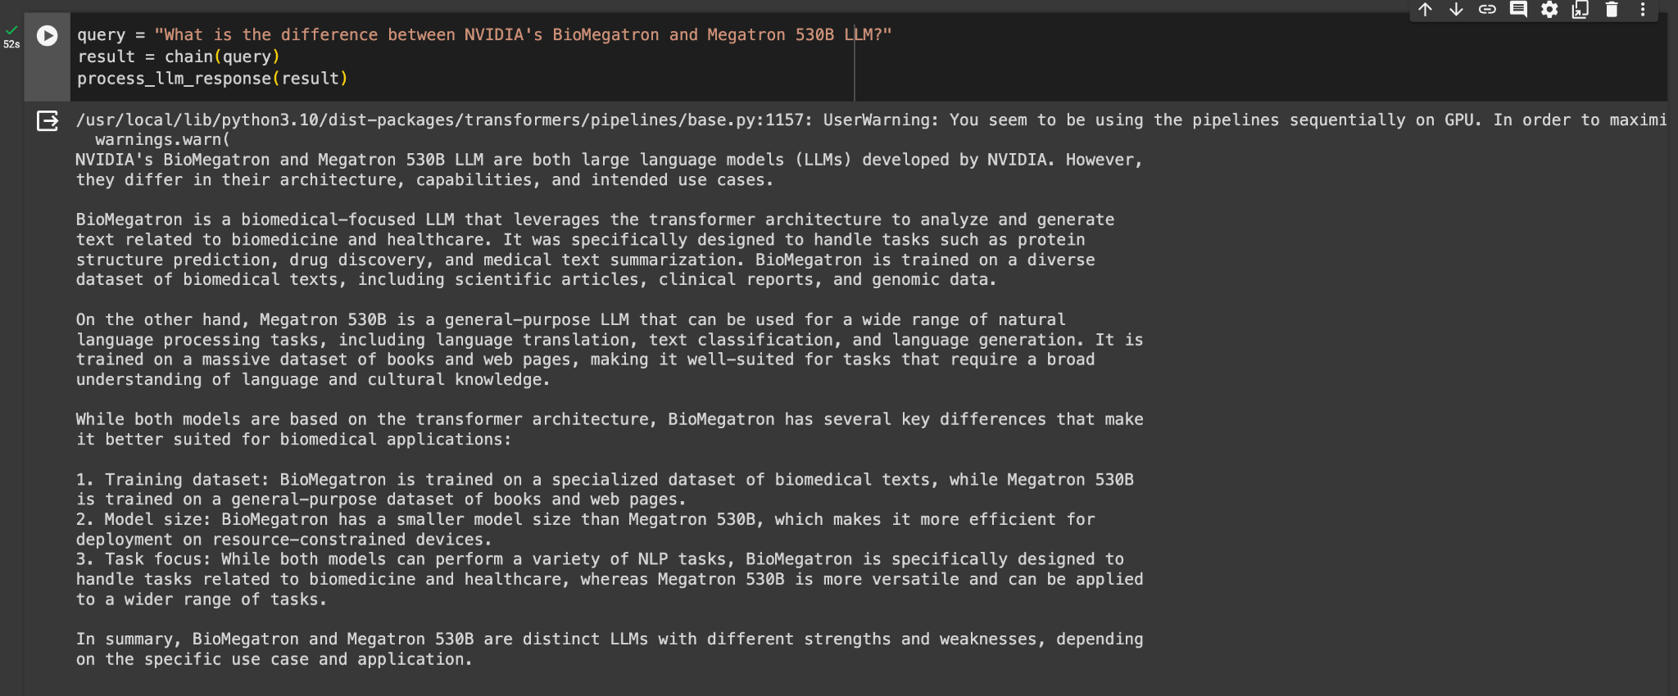

1. **"How to find the JetPack version of NVIDIA Jetson Device?"**

**Response 1**

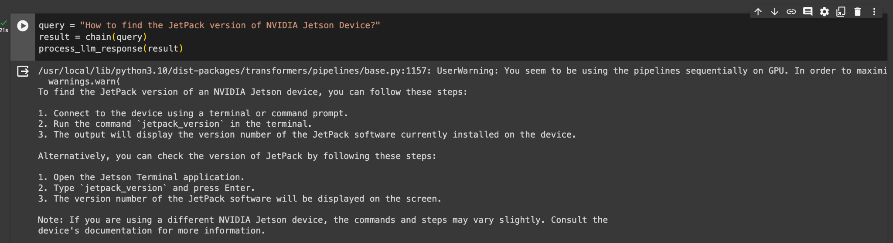

**Response 2**

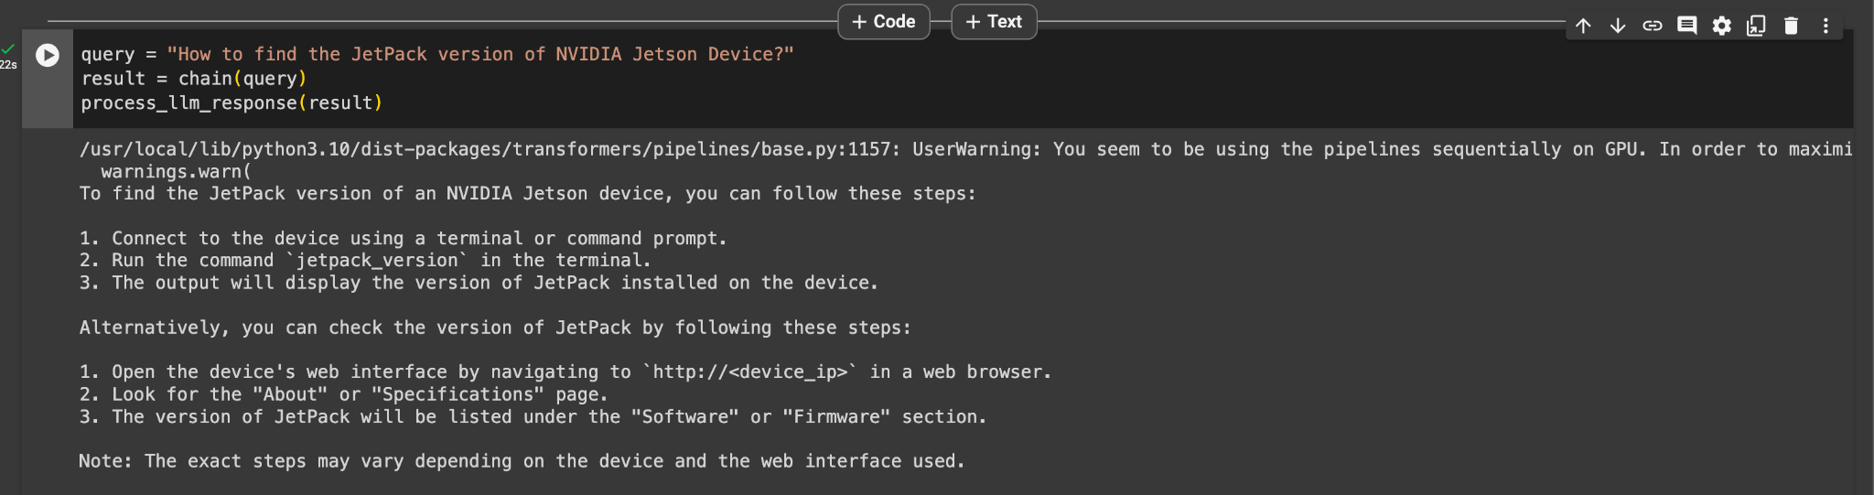

**Response 3**

